Software Requirement Specification

for

Atlantica Reservation Management Tool

Version 1.0 approved

Prepared by

Mohd Nawaz Hussain – Bharat Bhushan Verma – Ashwin Sivaraman – Sarbottam Thapa Magar – Kothai Kannappan Murugappan

Saint Mary’s University

14/11/2018

Table of Contents

Table of Contents ii

1. Introduction 1

1.1 Purpose 1

1.2 Document Conventions 1

1.3 Intended Audience and Reading Suggestions 1

1.4 Product Scope 1

1.5 Business Case 2

2. Overall Description 2

2.1 Product Perspective 2

2.2 Product Functions 3

2.3 User Classes and Characteristics 4

2.4 Operating Environment 4

2.5 Design and Implementation Constraints 4

2.6 Assumptions 5

3. External Interface Requirements 6

3.1 User Interfaces 6

3.2 Software Interfaces 10

4. System Features (Functional Requirements) 10

4.1 Functions 10

4.2 Use case 15

5. Nonfunctional Requirements 16

5.1 Performance Requirements 16

5.2 Security Requirements 16

Appendix A: Glossary 17

# Introduction

This section details the project introduction and will give the reader an overview of what the SRS document entails.

## Purpose

The purpose of this document is to give a detailed description of the requirements for the “Atlantica Reservation Management Tool” (ARMT) project. It will illustrate the purpose and complete declaration for the development of system. It will also explain system constraints, interface and interactions with other external applications. This document is primarily intended to be proposed to a customer for its approval and a reference for developing the first version of the system for the development team.

## Document Conventions

The document uses Italic and Arial 11 for general information that is pertinent to all the readers and those for whose eyes this document is intended for. For more in-depth information that deal with the more technical side of the project, a bold font will be used to highlight any convention that is required in terms of this project.

## Intended Audience and Reading Suggestions

The document is intended for use by the technical team who are writing this document and the developers who will be working on this project. It is also intended for the management team of both the project and Hotel Atlantica who can do as they will with the information presented in this document. It is suggested by the authors of this documents for the intended readers to have some background in software development and its conventions as it will ensure better understanding and readability of the language used in this document. The document contains technical terminology that some users might find confusing and any changes that deal with objectives related to the project. The readers of this document can go through some basic frameworks in relation to website creation, server-side scripting, synchronization of data to name a few that will benefit them greatly in terms of understanding the complex nature of the document as it goes further down the road.

## Product Scope

The scope of the project comprises of a web site that will grant advanced functionalities to the hotel owner, the customers and the payment providers. The three stakeholders will benefit from the various functionalities that will be implemented after gathering the various requirements in this project. The web system will improve cohesiveness between the three elements, allowing more productivity and accessibility for them.

The pre-existing website for the hotel will be replaced with this newer advanced one. Also, there will be changes made to how the technology operates in the background presently. The project will not take into consideration marketing and management operations of the hotel as it is beyond the scope.

## Business Case

Hotel Atlantica is based in the east coast of Canada. Atlantica is run by the hotel owner who oversees various operations conducted on a day to day basis. The hotel provides various types of rooms to the clients depending on the availability. Furthermore, the hotel offers various services such as a spa, restaurants for the customers to dine in or take away, and airport pick and drop.

With the growing market, and competition where Hotel Atlantica is based the company is facing financial difficulties. The competitors that exist currently are using the latest tools and technologies available at their disposable which is enabling them to attract customers from far and wide, which Atlantica has been unable to do.

Atlantica therefore, has understood it is pertinent in the current context to improve the technology. The hotel owner wants a website that is up to the task of the latest technological advancements in the world of web.

**FIGURE 1 – BLOCK DIAGRAM**

Therefore, the owner of the hotel has given us the task of improving this system and adding functionalities that will grant business value to Hotel Atlantica.

# Overall Description

*This section will give an overview of the whole system. The system will be explained in its context to show how the system interacts with other systems and introduce the basic functionality of it. It will also describe what type of stakeholders that will use the system and what functionality is available for each type. At last, the constraints and assumptions for the system will be presented.*

## Product Perspective

With the growing market, and competition where Hotel Atlantica is based the company is facing financial difficulties. The competitors that exist currently are using the latest tools and technologies available at their disposable which is enabling them to attract customers from far and wide, which Atlantica has been unable to do.

Atlantica therefore, has understood it is pertinent in the current context to improve the technology. The hotel owner wants a website that is up to the task of the latest technological advancements in the world of web.

Atlantica already has set up a website that is very basic in nature. The website showcases the information of the hotel and the rates that are available to book a room and the different types of rooms they have available for their clients. However, this is not intuitive nor good enough for the current market scenario that exists. The website that Atlantica needs and have passed the task onto the development team requires more functionality that can benefit all three entities that use the website. These are the hotel owner, the customer and finally the payment provider. The hotel owner is the management side of the website who can add material to the website that the current management provides for the website users. The customers are the entity who will use the website to book rooms and other services the hotel owner/the management will provide for the users of the website. Lastly, the payment providers are the third party who will provide official online e-transaction payment ability that will allow the hotel customers to book rooms and services by paying beforehand and reserving spots that are limited by the hotel management for any of the services that they provide.

## Product Functions

The product functions this document will target are as follows. In the current scope of the project, the hotel owner has asked for the following feature set to be implemented which are as follows:

Customer:

1. Customer will have a membership account that will allow them to get discounts at the hotel
2. The customers membership account will let them save their information on the database, so they can always login and go ahead with their booking
3. The customer can schedule an airport pickup and drop service from the hotel and can re-schedule it for any unforeseen reason
4. The customer account will save all their past transactions, so the customer can access a history of their past completed transactions
5. The customer can get alerts on their bookings (email) that will tell them about their schedule or even show newsletters to them underlining the new offers available
6. The customer should be able to view their payment status within the website
7. The website should have an event tab where the customers of the website can view any ongoing or scheduled events at the hotel
8. The website should allow the customers to pay for their booking online using their e-transaction method of choice

Hotel Owner:

1. The hotel owner should be able to have an online payment option on the website that allows him/her to receive payments from customers
2. The hotel owner should be able to give the first 5% of his customers every day a discount on their booking
3. The hotel owner should be able to release a restaurant menu on the website, so customers can see what food options are available by the day

Payment Provider:

1. The payment provider should be able to collect all the payments made in the website’s information so that they can process the data into information
2. The payment provider wants a payment API that will allow them to see all the payments made on a particular date
3. The payment provider should be able to show the customers all the payment they made directly (without logging into the payment providers web service)

## User Classes and Characteristics

There are three different types of users that will be using the product that is developed and are as follows:

The Hotel Owner: The hotel owner is someone who is in the management team of the hotel. It can be an individual or a management team of the hotel. They have control of the content that is visible on the website and what options are provided for the customers of the website and the payment provider. They are the owner of the current project that is being developed

The Customer: The Customer are the clients of the hotel owner and those who will rent rooms or use other services provided by the hotel owner. The project is being developed by taking into consideration their characteristics as the focal point. This is because the website has to be simple enough for any average user to use and engage with the hotel and their portfolio of available rooms and any other services that are provided by the hotel owner

The Payment Provider: The payment provider is the third party who provide the user with the functionality to make payments and give the payments to the hotel owner. The payment providers allow the user to securely and quickly make payments that will benefit both hotel owner and customer. It is pertinent to ensure that the payment providers methodologies are implemented perfectly as the payment of services is crucial to ensure the website functionality. The new website as opposed to the one that existed previously is the feature of booking rooms which the payment provider will allow the customers and hotel owner will receive the money from them.

## Operating Environment

The operating environment of the website will be on the internet. Therefore, we assume that any device running on the internet a browser, such as a smartphone, a laptop, desktop or even a video game console can be used to access the website. Basic packages for running the codes have to be implemented on the user end of the website such as the browser. But the operating environment has minimum constraints as it does not require much processing power or any additional addons for the user to run the website.

## Design and Implementation Constraints

The constrains that exist in implementing the website is the timeframe that will be set in the planning of building this website. Furthermore, we have to consider the restrictions imposed by the company developing this project and the timeframe the employees are working on this project.

The main constraints of this project is the provision of software resources to implement and test the performance of the website on different platforms. This is important as the assumption of the software running on the various platforms cohesively over the website has to be tested to a maximum degree to ensure the final product is useable in a wider scenario.

Furthermore, another constraint is the connection to the world wide web always. Since we assume the website will always be on, we need to ensure our server synchronization is always switched on and the information received and shown can always be available to all those who are using the website

The programming standards followed in this project will have to match with the documentation that is found online on the language developers’ website. This is to ensure that the uniformity of code exists, and later changes and subversions can be easily implemented by the developing team.

The last constraint is the organization responsible for maintaining the website. We are assuming the product owner will hire the developing team to maintain and update the website as time goes on.

## Assumptions

The following are the assumptions we have made in respect to this project:

* The hotel owner receives the payment made to the payment provider in a different system. The functionality for the payment provider to pay the hotel owner, is not incorporated in the ARMT system.
* We assume that the servers are online 24/7, so the system is always online and does not require intervention by the payment provider (a human intervention) at any given time to confirm a payment.

# External Interface Requirements

## User Interfaces

Fig 2: Customer Login Page

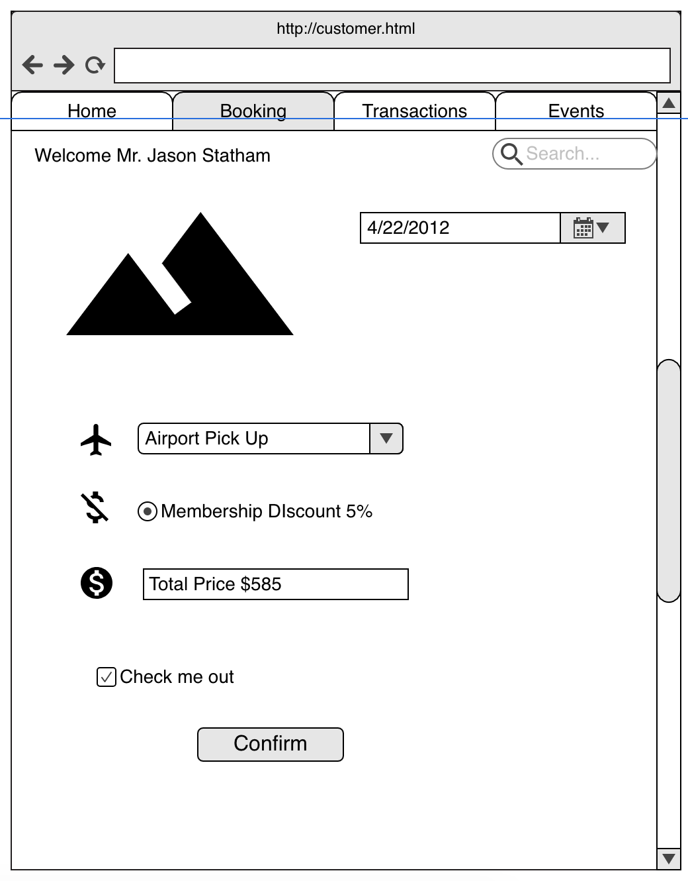Fig 3: Customer Check Out Page

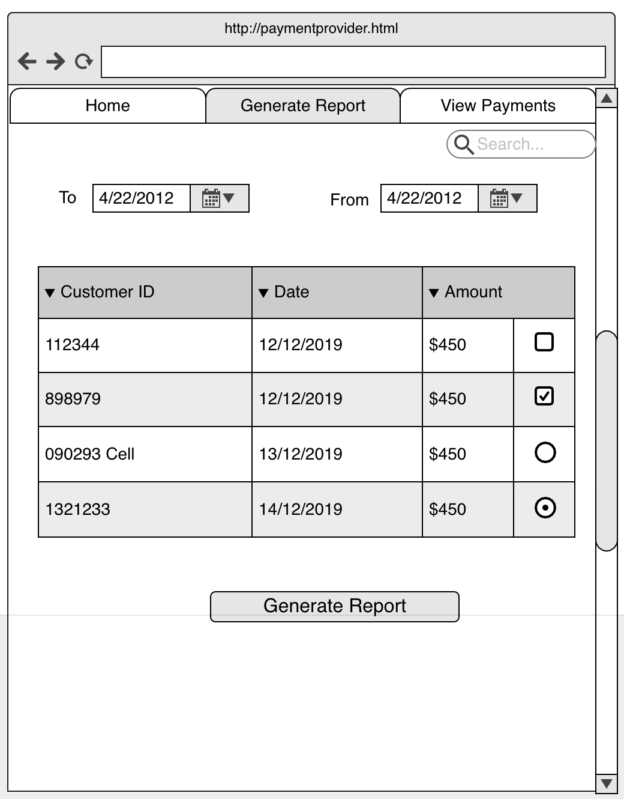Fig 4 Payment Provider Generate Report

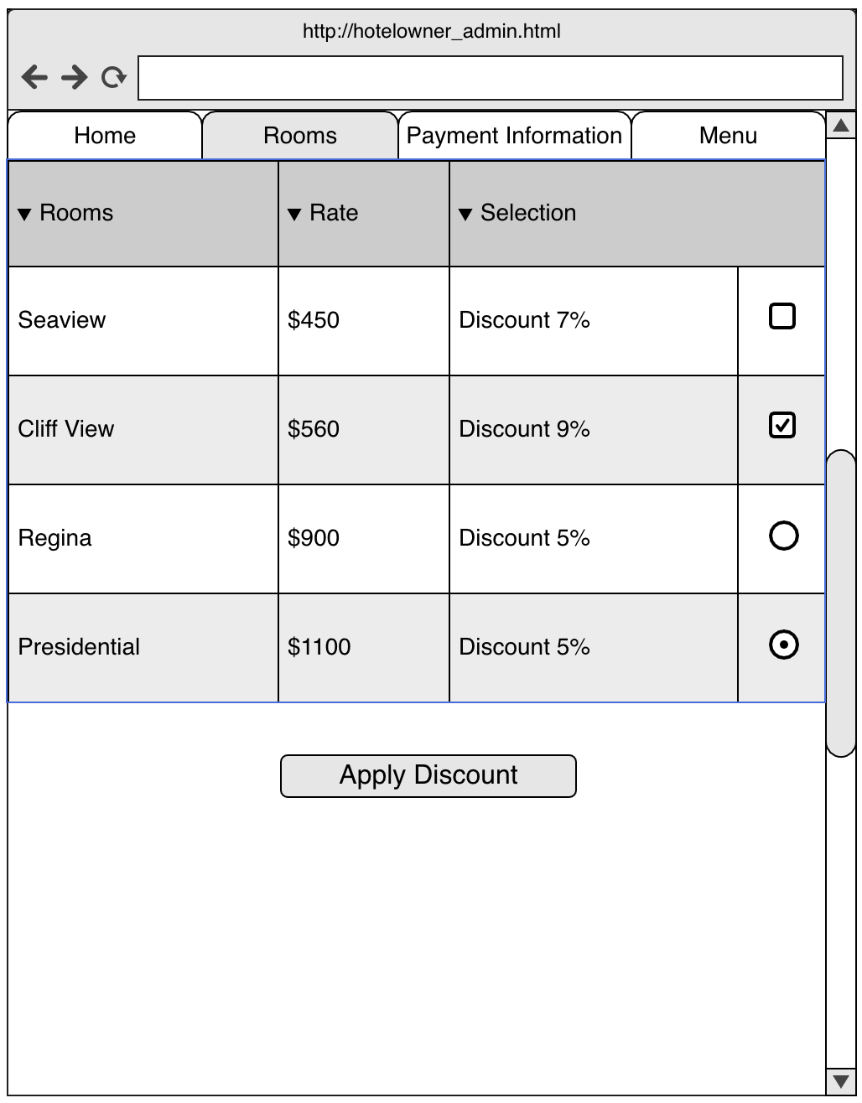Fig 5 Hotel Owner discount application page

## Software Interfaces

The software uses a web-based interface to communicate across to all three levels of the user. The interface is based on the server and this allows the users access to the system and the functionality they require any time as long as the server is active. This allows

# System Features (Functional Requirements)

## ER Diagram

## Functions

**ID: FR1**

Title: Member Customer Special Discounts

Description: The customer who is a member of the Hotel Atlantica receives a special discount pre-set by the hotel owner on their booking for being a member.

Step-By-Step Description:

1. The customer logins with their credentials (username and password)
2. The customer is logged in
3. The customer selects their hotel room
4. The customer selects the stay period
5. The customer is taken to the payment page
6. The payment page shows the normal price and the discounted price
7. The customer selects payment method
8. The customer makes the payment
9. The payment received is the discounted amount

**ID FR2**

Title: Payment Provider Views All Payments in Database and generates report

Description: The payment provider can see all the payments made by the customers of the hotel in the database and generate a report over a period of time

Step-By-Step Description:

1. The payment provider accesses the payment database
2. The database synchronizes with the server when accessed to grab the latest data from the server
3. The payment provider enters the ‘To’ and ‘From’ dates from the drop down menu present
4. The payment provider clicks generate
5. The data from the entered period is exported as a CSV file
6. The CSV file is available to download
7. The payment provider downloads the file
8. The payment provider opens the file

**ID FR3**

Title: Customer re-schedules their airport pickup shuttle time

Description: The customer can re-schedule their airport pickup timing because of delays for any number of reasons

Step-By-Step Description:

1. The customer enters their information into the hotel website using their credentials
2. The customer is logged in based on the verification of their credentials
3. The customer goes to their booking tab
4. The customer selects the required booking
5. The customer moves to the airport pickup tab
6. The customer clicks edit
7. The customer enters the new date and time for the pickup
8. The date and time should fail if it is within the next 12 hours from the time of the current edit
9. The system accepts the customer values
10. The system shows the customer the success message and their updated timing

**ID FR4**

Title: Payment details page for the customer

Description: The customer can view the payment details about a payment made previously

Step-By-Step Description:

1. The customer enters their information into the hotel website using their credentials
2. The customer is logged in based on the verification of their credentials
3. The customer goes to their booking tab
4. The customer selects the booking they want
5. The booking is displayed to the customer
6. The customer clicks the detail button
7. The details page is shown
8. The detail page shows their payment amount and status (received, in-process, error)
9. The customer can print the details

**ID FR5**

Title: Customer member status saves their contact information

Description: By being a member of Hotel Atlantica registration instead of booking as a guest, the customer can save their contact information

Step-By-Step Description:

1. Customer goes to the hotel Atlantica page
2. Customer clicks on register
3. Customer enters their details
4. Validation is carried on the customer details
5. If the inputs satisfy the pre-determined criteria
6. The customer is logged in and his/her contact information is saved

**ID FR6**

Title: Hotel owner can show the various menus on the website

Description: The hotel owner inputs the various menus on the hotel website so the customers can view and order from the comfort of their room

Step-By-Step Description:

1. Hotel owner opens the admin selection from the website
2. Hotel owner clicks on the menu tab
3. Hotel owner selects the restaurants from the drop down menu
4. If the restaurant does not exist the hotel owner creates a restaurant object
5. The hotel owner enters the restaurant details (Name and Number)
6. The hotel owner clicks on add menu
7. The hotel owner is prompted with a dialog box that asks for upload
8. The hotel owner selects the image of the scanned menu from their system
9. The hotel owner clicks okay
10. The image is uploaded to the database
11. The owner is prompted with success
12. The customer can login and see the menu

**ID FR7**

Title: Payment provider can see all payments on a date

Description: The payment provider can select a date and view all the payments made to the hotel by the customers on a particular date

Step-By-Step Description:

1. The payment provider opens the Hotel account on their system
2. The payment provider selects the view payments
3. The payment provider selects a date from the drop-down calendar
4. The payment provider can see all the payments made on the date

**ID FR8**

Title: Customer can see previous bookings

Description: The customer can see their previous bookings and compare prices to what they paid

Step-By-Step Description:

1. The customer enters their details in the login page
2. The customer is logged in after verification
3. The customer goes to their booking tab
4. The customer selects their view all bookings
5. The customer can see all their previous bookings
6. The customer can hover over each booking
7. The popup shows the current rate versus their previous rate paid for the same room

**ID FR9**

Title: Customer gets alerted on bookings and new deals

Description: The customer gets alerted on bookings and any new deals the hotel customer puts up on the system

Step-By-Step Description:

1. The hotel owner goes to the deals page on his portal
2. The hotel owner selects the new deal
3. The hotel owner enters the details of the new deal
4. The hotel owner selects the duration of the deal
5. The hotel owner clicks Apply
6. The system sends an email regarding the deal to customers
7. The customer enters their details in the login page
8. The customer is logged in after verification
9. The customer can see a notification beam
10. The customer clicks on the beam
11. The customer can see the deal posted by the hotel owner

**ID FR10**

Title: Customer can see events and scheduled events

Description: The customer can view ongoing and scheduled events happening in the hotel and the details regarding these events

Step-By-Step Description:

1. The customer enters their details in the login page
2. The customer is logged in after verification
3. The customer clicks on the events tab
4. The customer can see the current events at the hotel
5. The customer clicks on future events
6. The customer can see the future events details

**ID FR11**

Title: Hotel owner can provide 5% complementary discount for first 5% of customers everyday

Description: The hotel owner can add a 5% discount for the first 5% of customers everyday if he/she wants

Step-By-Step Description:

1. The hotel owner accesses their admin portal
2. The hotel owner selects the Rooms tab
3. The hotel owner can see the 5% discount function
4. The hotel owner clicks the function
5. The pop up appears
6. The hotel owner can select the percentage discount
7. The hotel owner selects apply
8. Confirmation message asks if he/she is sure
9. Hotel owner clicks okay
10. Discount applied for first 5% of people who books on that day

**ID FR12**

Title: Payment provider offers customer specific portal

Description: Payment provider offers customer a portal into their own website that allows the customer to see the transaction details directly without being redirected to the payment provider website

Step-By-Step Description:

1. The customer enters their details in the login page
2. The customer is logged in after verification
3. The customer clicks on their payment tab
4. Customer selects a transaction from the list displayed
5. The website grabs the information from the payment provider database
6. The customer can view the payment information including the transaction number from the payment provider

**ID FR13**

Title: Hotel customer webpage online payment

Description: The customer can have a webpage online where they can make a payment

Step-By-Step Description:

1. The customer goes to the hotel website
2. The customer selects the room they want
3. The customer selects pay
4. The customer is prompted either to login/signup or continue as guest
5. The customer selects either
6. The customer enters their payment details
7. The payment is completed

**ID FR14**

Title: Hotel owner requires payment processing on website

Description: Hotel owner requires an online payment processing system in the website

Step-By-Step Description:

1. The hotel owner opens his admin portal
2. The hotel owner selects the payment processing tab
3. The tab uses the technology implemented by the payment provider
4. The payment provider allows the hotel owner to process payment

## Use case

A single use case diagram to illustrate the Payment Provider Generating a report

|  |  |  |
| --- | --- | --- |
| Use case Name | Payment Provider Generates report |  |
| Goal | Payment provider generates report of the payment over a duration |  |
| Primary Actors | Payment Provider |  |
| Secondary Actors | Customer |  |
| Precondition | Atleast one transaction between customer and hotel has to exist in the time period |  |
| Post condition | The report should be generated with all fields |  |
| Triggers |  |  |
| Main flow | Step | Action |
|  | 1 | Customer makes a transaction in intended time frame of report |
|  | 2 | Payment provider Access the payment page |
|  | 3 | Database synchronizes the server with all the information upto the Access time |
|  | 4 | The payment provider enters the ‘To’ and ‘From’ dates from the drop down menu present |
|  | 5 | The payment provider clicks generate |
|  | 6 | The data from the entered period is exported as a CSV file |
|  | 7 | The CSV file is available to download |
|  | 8 | The payment provider downloads the file |
|  | 9 | *The payment provider opens the file* |
| Extensions |  |  |
|  |  |  |

# Nonfunctional Requirements

## Performance Requirements

*For the system to perform optimally, we require the system to update in real time from the various portals it is accessing. The performance of the website should be optimized in this regard to give the users of the website that is the customers an optimal experience that will enrich their experience and make them want to use the website. The work on this project becomes redundant if the performance is affected based on factors that are under the control of the project management team. Therefore, the queries and transfer of information have to be optimized to ensure the performance is good for the customers as well as the hotel owner to post his/her input on the website as they wish so.*

## Security Requirements

Since the website deals with payment, security protocols have to be followed. To ensure security over the payment, we are using the third-party API provided by the payment provider as they have acquired all the security certifications that enable them to conduct online payments and any processes related to such. Also, we require the users to run an antivirus of any kind on their system for their own safety, to ensure that any private information entered on the portal such as names, contact info, etc. should remain sealed from being revealed to strangers over the internet.

Appendix A: Glossary

ARMT: Atlantica Reservation Management Tool